Конференция исследовательских проектов школьников
«Учение с увлечением» для 5-11 классов в 2017-2018 учебном году
_________________________________________________________________
Частное образовательное учреждение Школа «Экология и Диалектика»

АНГЛИЙСКИЙ ЯЗЫК В МОЕМ РАСПИСАНИИ

«English is a lesson in my schedule»
Секция АНГЛИЙСКИЙ ЯЗЫК

Автор - Ел Райес Григорий
Класс -5
Руководитель – Пророк Наталия Владимировна,
учитель английского языка первой квалификационной категории
ЧОУ Школа «Экология и Диалектика»

Бердск 2018
Contents
p
- Introduction 3
- Main part 5
1. Theoretical part 5
1.1. History of the English language 5
1.2. The role of English in the modern world 6
2. Practical part 8
2.1. The results of the questionnaire survey 8
2.2. The reasons for learning English 8
- Conclusion 10
- List of Internet resources 11
- Supplements 12

- Introduction
Hello, my name is Grigory. My favorite subject is English. I have been studying English since birth. My family speaks this language. I have many foreign friends. I communicate with them in English. It's very easy for me to learn English at school. In English lessons we read and translate texts, teach rules and new words and try to understand each other. Many of my Russian friends don’t want to learn English. This subject is very difficult for them. They ask our teacher: «Why do we study English? »
I decided to do the project«English is a lesson in my schedule» to show the importance of learning English. I hope my project encourage my Russian friends to learn hard. Perhaps somebody of them will be interested in studying English, as I’m interested in it.
The actuality of the problem. The English language is the most widely spoken language in the world. English is one of compulsory subjects in Russian schools. Many students like to study English. But there is a group of children who learn English because everybody does it or their parents tell them to do it. I’m sure it is important to show the students that learning English is necessary for them.
The aim of the work- to show the importance of the English language for Russian students in modern life.
The tasks of the work:
- To study information on Internet sites about the English language.
- To know the reasons for studying English.
- To interview the students of our school.
- To analyze the opinions of our students.
- To create a booklet «I love English».
The subject of the work- English is one of the subjects in the schedule of Russian student.
The objects of the work - Internet sites and the students of my school.
Hypothesis - English isn’t just a school lesson but it’s also a necessity for all Russian students in the modern world.
The methods of investigationare research, review, comparison, description and analysis.
Resources are Internet sites.

- Main part
1. Theoretical part
1.1. History of the English language
The history of the English language started with the arrival of three Germanic tribes who invaded Britain during the 5th century AD. These tribes, the Angles, the Saxons and the Jutes, crossed the North Sea from what today is Denmark and northern Germany. At that time the inhabitants of Britain spoke a Celtic language. The Angles came from "Englaland" and their language was called "Englisc" – from which the words "England" and "English" are derived.
Old English did not sound or look like English today. Native English speakers now would have great difficulty understanding Old English (Supplement 1).
In 1066 William the Conqueror, the Duke of Normandy invaded and conquered England. The new conquerors brought with them a kind of French, which became the language of the Royal Court, and the ruling and business classes. For a period there was a kind of linguistic class division, where the lower classes spoke English and the upper classes spoke French. In the 14th century English became dominant in Britain again, but with many French words added. This language is called Middle English. It was the language of the great poet Chaucer, but it would still be difficult for native English speakers to understand today (Supplement 1).
Towards the end of Middle English, a sudden and distinct change in pronunciation (the Great Vowel Shift) started, with vowels being pronounced shorter and shorter. From the 16th century the British had contact with many people from around the world. Many new words and phrases entered the language. The invention of printing also meant that there was now a common language in print. Books became cheaper and more people learned to read. Printing also brought standardization to English. Spelling and grammar became fixed and the dialect of London where most publishing houses were, became the standard. In 1604 the first English dictionary was published (Supplement 1).
The main difference between Early Modern English and Late Modern English is vocabulary. Late Modern English has many more words, arising from two principal factors: firstly, the Industrial Revolution and technology created a need for new words; secondly, the British Empire at its height covered one quarter of the earth's surface, and the English language adopted foreign words from many countries.
  - The role of English in the modern world
Half a century ago English was just one of the international languages accepted in the world. As the time passed the role of English in the society has increased. Every adult in the world dreams to learn the English language. On top of that they want their children to know English well. There are many reasons for that.
First of all you can travel around the world without problems. Whether it’s a European, African or Asian country people will understand you if you speak English. Now there are international conferences, exhibitions where you can meet interesting people, learn about the culture of other countries, their traditions. Exchange of students and students, international training is also not uncommon.
Secondly, all businesses in the world are done in English today. The English language is necessary in every field of the knowledge. There are many professions where English is needed: diplomats, scientists, travel agents, journalists. The students know that English plays the great role in education and their future career. If they learn English well, they will get high salary and career growth.
Thirdly, a lot of books and periodicals are written in the English language. Most Internet sites and pages are composed in English. All computer programs and applications use this language. Many famous films, TV shows and songs are in English. All important international sports competitions, the main of which are the Olympic Games, are held in the English language.
This list can continue endlessly but the most important thing is everyone in modern society understands how important English today. An educated person should know a foreign language because cooperation between people of different countries is impossible without the knowledge of the English language. Modern English is the dominant language of communications, science, information technology, business, seafaring, aviation, entertainment, radio and diplomacy. Knowing English provides a great opportunity for material well-being and a successful life (Supplement 2).

- Practical part
  - The results of the questionnaire survey
In practical part of my research I used methods: review, comparison, description and analysis.
To study the information of Internet sites I was interested in opinions of our school students. I made a survey among 10 students of the 5th-7th forms of our school. I wanted to know the role of English in their life (Supplement 3).

*Do you want to learn English?
The results of the questioning showed that students (Supplement 4):
- want to learn English (90%),
- not want to study English (2%),
- found it difficult to answer (8%)

*In your opinion, will your life be connected with the English language?
The results of the questioning showed (Supplement 4):
- for the use of the Internet (100%),
- for computer games (45%)
- for viewing films, listen to songs in the original (30%),
- for travel (25%),
- to communicate with foreigners (15%).
I understood our students often use the English language. But some children don’t want to learn English. For this group I continue my research. I decided to show them that English is necessary.
2.2. The reasons for learning English
I suggested all comers writing compositions «English is necessary for Russian students» (Supplement 5).
The results of compositions showed that students have many reasons for learning English.
- To communicate with people of the world
- To use when you travel
- To use of the Internet
- To get a better job
- To understand English
To sum it up I can make a conclusion. The reasons for learning English and English in the students’ life are the same. English has become a part of our life. Practical part of my research shows that knowledge of English is necessary. I hope that everybody will find own way of learning English even if it is difficult. For them and other people I created a small booklet «I love English»where you can read many interesting things about English (Supplement 6).

- Conclusion
In the course of my work I learned interesting and important facts from history of the English language.
Using the Internet I knew that English is the language of science, medicine, technologies, literature and so on.
I found out that English is the main source of communication with people of different countries.
I also made survey students of our school to know the purpose of studying English and the role of English in their life.
I understood our students often use the English language. But some children don’t want to learn English. For this group I decided to show that English is necessary. I suggested writing compositions «English is necessary for Russian students».
The compositions of the children showed that some of them travel a lot and English helps to communicate with people. Other children are fond of computers and they use computer programs in English. Some students are interested in reading English books in the original. My friends like music. English helps them to understand and sing songs. And they believe the English language will allow to get a good job and earn good money in future. Analyzing different opinions I came to the conclusion that to know English today is absolutely necessary for every educated person.
After the survey I created a small booklet «I love English»where my friends can read many interesting things about English. If you read my booklet, I will be very glad. I promise it will be very useful for you.
I believe that based on information and research results my hypothesis " English is not only a lesson in the school schedule but also a "lesson" in life for each of us" is true.
The purpose of my work is done.

- List of Internet resources

- http://marina58.ru/index.php/blog/item/126-rol-inostrannyx-yazykov-v-zhizni-cheloveka
- https://www.google.ru/
- https://en.wikipedia.org/wiki/History_of_English
- http://www.vistawide.com/languages/languages.htm
- http://grammar.about.com/od/grammarfaq/f/whystudylanguagecrystal.htm
- http://www.whystudyenglish.ac.uk/you-are/index.htm
- http://www.ecenglish.com/learnenglish/lessons/why-learn-english-all-competition-entries

- Supplements
Supplement1
The first page of the Beowulfmanuscript

The approximate extent of Old Norse and related languages in the early 10th century:
Old West Norse dialect
Old East Norse dialect
Old Gutnish
Old English
Crimean Gothic
Other Germanic languages with which Old Norse still retained some mutual intelligibility

Opening prologue of "The Wife of Bath's Tale" from the Canterbury Tales

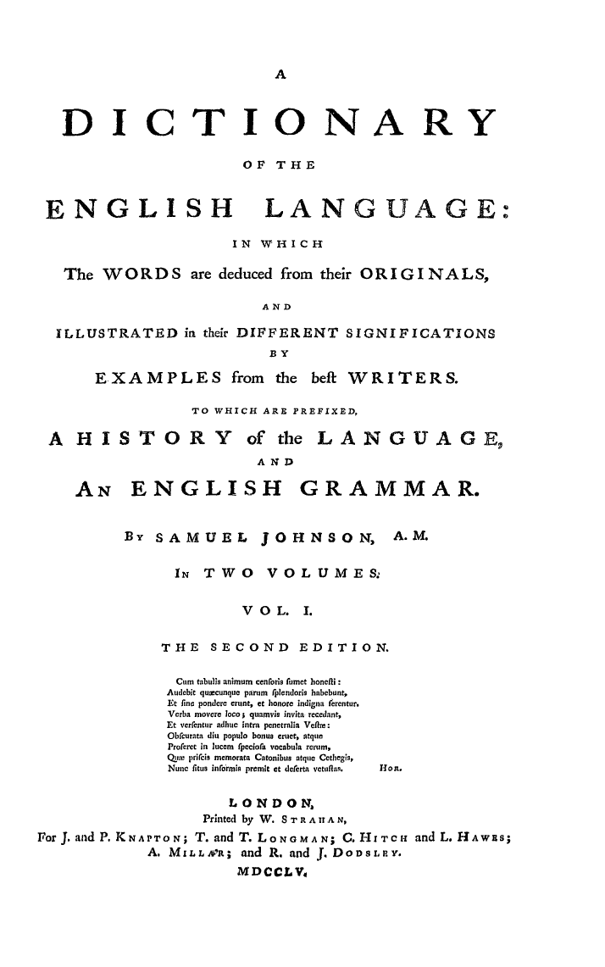
Title page from the second edition of the Dictionary

Supplement2

Do you know that..?

- The English language is now the first language of about 450 million people, the native language of 12 nations and the official or semiofficial language of 33 more nations. That means one in every seven people in the world speaks English.
- 80% of all information in the computers’ world is English.
- 75% of all international letters and telexes are in English.
- More than half of the world’s periodicals are printed in English
- 50% of all the companies in Europe communicate with one another in English
- English is so popular because the United Kingdom used to have a big empire. The British had colonies all over the world, and all the people in the colonies had to speak English.
- Learn English and you’ll be able to travel all over the world!

Supplement 3
Interview

1. Do you want to learn English?
2. In your opinion, will your life be connected with the English language?

Thank you for attention!

Supplement 4
The results of the questionnaire survey
*Do you want to learn English?
*In your opinion, will your life be connected with the English language?

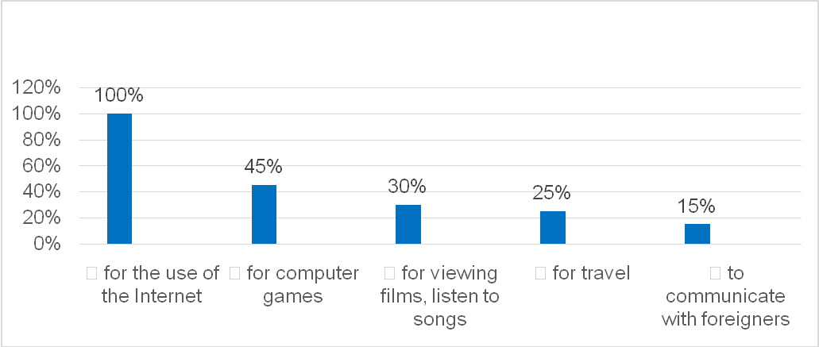

Supplement 5
Compositions «English is necessary for Russian students»
Alina Shushakova (5 class)
Englishis subject in our school program. I have English three times a week. Learning English helps me to choose the future profession. I want to be ajournalist because it’s a very interesting job.English helps me to work with computer and understand songs in English.
I’m sure that learning foreign languages is necessarybecauseknowledge of foreign languages helps to make a person educated.
Yulia Teske (6class)
I learn English at school.I like songs in English. Learning foreign languages is very useful. It helps meto understand the English text. I listen to music about different people’s stories, about love, friendship, art, nature.
Learning languages is a good exercise for the intellect. It gives us a chance to get a better job and to visit other countries.

Alex Kuznetsov (7 class)
I began to learn English at the age of eight. It wasn’t very interesting for me because I didn’t understand it. Now I study at English courses. I would really like to read different poets, writers in the original language.
English is one of the most important languages. It is necessary. It helps tounderstand and communicate with people from different countries.

Daria Buharova (7 class)
I study English at school. English is the most popular language in the world. I think this language is very useful in my life. I travel a lot. It helps me to communicate with people from other countriesand to make new friends.
In our time it is very important to know foreign languages.

Supplement 6
A booklet «I love English?»

